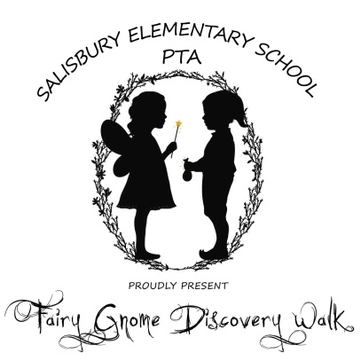
Fairy Gnome Discovery Walk will welcome hundreds of local families for a magical day of exploration, inspiration, and community.
For a contribution of $50, your company will be provided with a fairy or gnome house door to be displayed somewhere on your premises – ideally where children can “happen upon it.”
In the whimsical spirit of the event, your company will be acknowledged with “magic dust” spread throughout our local communities:
Your business name will magically appear on our Facebook page (several thousand followers) and Event Website as a Fairy and Gnome host
Door Seekers – children and their families will be encouraged to find doors that will be “installed” throughout the community;
Contributors’ doors will be displayed at the Discovery Walk, along with plaques highlighting your support;
Most importantly, feel good about participating in a very special event in a very special community.
We hope your business will consider supporting this community event, the proceeds of which will benefit the Salisbury Elementary School (SES) PTA in our ongoing efforts to support our school, teachers, and students.
A whimsical afternoon at Salisbury’s most beautiful farm,
PETTENGILL FARM
walk through lush gardens, an enchanted forest, and the serene marsh; it’s an event like no other.
ABOUT THE EVENT
Join us at our second annual Fairy Gnome Discovery Walk at Pettengill Farm on Rings Island, Salisbury. The gems of the event are the 100+ Fairy and Gnome Homes peppered throughout a 1 mile wooded path that leads to the marsh and back. Homes are created by talented professionals, families, school children, and local businesses. The event will have Fairy Tales read in the woods, live music, performances, Newburyport’s Theater in The Open, Author visit: Tracy Kane, children’s crafts, food offerings, and so much more! Last year’s inaugural tour drew over 700 attendees and based on early ticket sales and the several thousand social media following we are anticipating an even bigger event this year.
Fairy Gnome Discovery Walk
Pettengill Farm
45 Ferry Road
Salisbury, MA
Saturday, May 21st 10-3- Washout Date: May 22nd

Business: __________________________________________________________
Contact Person: _____________________________________________________
Address: ___________________________________________________________
Email: ___________________________ Phone: ___________________________
Sponsor: $50.00______ Additional amount: _________ Total: _____________
_____YES, in addition to my sponsorship, I would love to make a fairy/gnome house
Please make checks payable to SES PTA and Note: “Fairy/Gnome Walk”.
Thank you for supporting our event!

Salisbury PTA
100 Lafayette Road,
Salisbury, MA 01952
(781) 426-1559
SalisburyPTA@GMail.com
For more information, please visit our website: www.FairyGnomeWalk.Weebly.com
https://www.facebook.com/FairyGnomeHouse

SES PTA are recognized 501 (c) (3) not-for-profit

