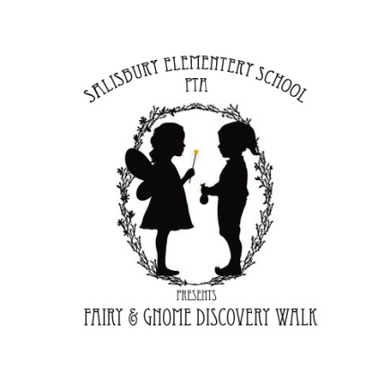
Wanted: Fairy & Gnome House Builders!
Saturday, May 21st
^{Rain Date May 22nd}
10am – 3pm Pettengill Farm.
45 Ferry Road, Salisbury. MA
﻿

“…the simple challenge of creating a fairy house gives children a unique activity that encourages them to go outside and connect with the natural world, nurturing care and respect for the environment.” ~ Tracy Kane, Fairy House book series

Salisbury Elementary School (SES) PTA cordially invite you to participate in our Fairy Gnome Discovery Walk on Saturday, May 16th from 10AM – 3PM located on Pettengill Farm’s enchanted grounds. We hope that you will join and support us by creating your very own fairy or gnome home to display at our walk.

Guests of the discovery walk are invited to explore the farm grounds to view your home. Local librarians will read fairy tales, dancers will perform fairy dances, performances will be enjoyed, and musicians will perform throughout the day. Admittance: $5 per person, $15 family. (Children ages 2 and under are free.)

This community event is a wonderful opportunity for your group or business to get creative and show just how magical you are! Proceeds from this event will benefit SES PTA.

Please spread the word and help us make a magical event for all. Questions? Contact SES PTA, SalisburyPTA@gmail.com

For more information and ticket purchases please visit: FairyGnomeWalk.weebly.com
Facebook.com/FairyGnomeHouse

Fairy Gnome House Submission Form
Yes! I would like to build a Fairy Gnome House for the Fairy Gnome Discovery Walk on May 21st (rain date May 22nd), at Pettengill Farm.
Please complete and mail this form to Jennifer Roketenetz, c/o SES PTA, 100 Lafayette Road, Salisbury, MA, 01952, or fill out a form online at FairyGnomeWalk.weebly.com
Name of Participant:______________________________________________________________________
(individual, organization, school, class, scout troop, business or family)

Contact Name: __________________________________________________________________________

Address: _______________________________________________________________________________
(Street Address, City, State, Zip)

Daytime Phone:__________________________

Email: _________________________________________________________________________________

Name of Fairy House(s) - if applicable:_______________________________________________________

Permission:
I Agree and give full permission
I understand that the exhibit will be unguarded and located outside in a designated area on the tour. I will not hold any party responsible for any damage to the exhibit by individuals, animals, weather, etc. I give permission for quotations and photographs of me and my exhibit(s) to be used for all purposes and in all forms, including print, websites, etc.

DELIVERY & INSTALLATION
Your completed house should be brought to Pettengill Farm (45 Ferry Road, Salisbury) for installation on May 20th from 4-6PM. If you are unable to deliver your fairy house during the drop off hours, please contact us (SalisburyPTA@gmail.com) and we will try to make other arrangements for you.
Small signs will be provided for you to display a name of your fairy house or you may use your own, if you wish.
Houses may be picked up at 3PM. Fairy Gnome Discovery walk will not be held responsible for any house left after tour. We ask that you do not remove your house before the designated time.

